
Analyzing some of the top 5 SEO companies that charge thousands of dollars for audits of companies' websites and webpages. I am looking for what they mostly provide, as well as some of the most premium templates that you would be able to find online of how they would present the data.
Perfect! Now I have all the information I need to provide a comprehensive response. Let me compile the final answer.
Top 5 Premium SEO Audit Companies and Their Service Offerings
The premium SEO audit market has established itself through comprehensive service delivery and strategic recommendations for enterprises. Here's an analysis of the top five agencies that charge thousands of dollars for their audits:
1. WebFX
WebFX positions itself as a market leader with custom SEO audit plans starting at $8,600 per month. Their 360° SEO audit process spans 45 days and delivers extensive deliverables. The company invests over $50 million in proprietary technology to provide clients with enterprise-grade tools.^{[1][2]}
What They Deliver:
- On-page, off-page, and technical SEO audits
- Up to 70 pages reviewed with detailed analysis
- In-depth competitor analysis scorecards (covering up to 3 competitors)
- AI-boosted content optimization and advanced content analytics
- Complete audit implementation training and support (up to 2.5 hours)
- DIY or full implementation support options
- Future site strategy roadmap and action plan^{[1]}
Key Differentiator: WebFX emphasizes custom solutions tailored to business goals, with a 750+ person digital strategy team providing expert oversight.
2. Single Grain
Single Grain specializes in AI-powered technical SEO for growth-stage companies. Their approach focuses on identifying and fixing complex technical barriers that specifically impact revenue growth rather than just traffic metrics.^{[3]}
What They Deliver:
- Comprehensive crawl analysis using enterprise-grade tools
- Core Web Vitals and JavaScript rendering evaluation
- Competitive technical gap analysis
- ROI-focused prioritization of fixes based on projected business impact
- Keyword gap auditing and cannibalization analysis
- NLP optimization for AI search readiness
- Programmatic SEO implementation guidance^{[3]}
Notable Results: Clients have achieved 2,000% increases in SEO visibility and 195% traffic growth after audits.^{[3]}
3. Thrive Agency
Thrive takes a holistic, business-aligned approach to SEO audits, integrating SEO findings with broader digital marketing strategy.^{[4]}
What They Deliver:
- Technical foundation optimization with detailed crawl issue discovery
- On-page auditing covering metadata, internal linking, and keyword placement
- Comprehensive backlink audits identifying harmful links and authority opportunities
- Domain authority and trust signal assessment
- Content gap analysis revealing underperforming pages
- Priority-based recommendations tied to traffic volume and revenue potential
- Enterprise-scalable audits handling thousands of pages^{[5]}
Unique Approach: Rather than just identifying issues, Thrive connects findings to business impact, helping clients understand which fixes will drive the most significant revenue increases.
4. NP Digital
NP Digital excels in content structuring and site architecture optimization. Their audits emphasize how search engines understand and navigate website hierarchy.^{[6]}
What They Deliver:
- Website hierarchy and structure analysis
- Structured data implementation for pillar pages and content clusters
- Comprehensive evaluation of technical SEO issues
- Broken links, site structure, and load time analysis
- E-A-T signal evaluation (Experience, Expertise, Authoritativeness, Trustworthiness)
- Internal and external link profile assessment
- Actionable recommendations for architecture improvements^{[7]}
Notable Results: One financial services client saw a +210% increase in non-branded organic search clicks and +33% increase in top 10 keyword rankings year-over-year.^{[8]}
5. Salt.agency (SALT)
Salt.agency pioneered Edge SEO and operates a 300+ point technical SEO framework for comprehensive site auditing.^{[6]}
What They Deliver:
- Extensive technical SEO audits using proprietary 300+ checkpoint framework
- SEO strategy and international SEO specialization
- E-commerce and enterprise local SEO services
- Organic traffic drop and recovery analysis
- Edge SEO optimization (cutting-edge performance technology)
- Site architecture optimization for crawl efficiency
- Core Web Vitals and JavaScript framework expertise^{[6]}
Scope: Covers technical elements like crawl budgets, canonicalization, and complex JavaScript implementations that many standard audits miss.

Premium Report Presentation Formats
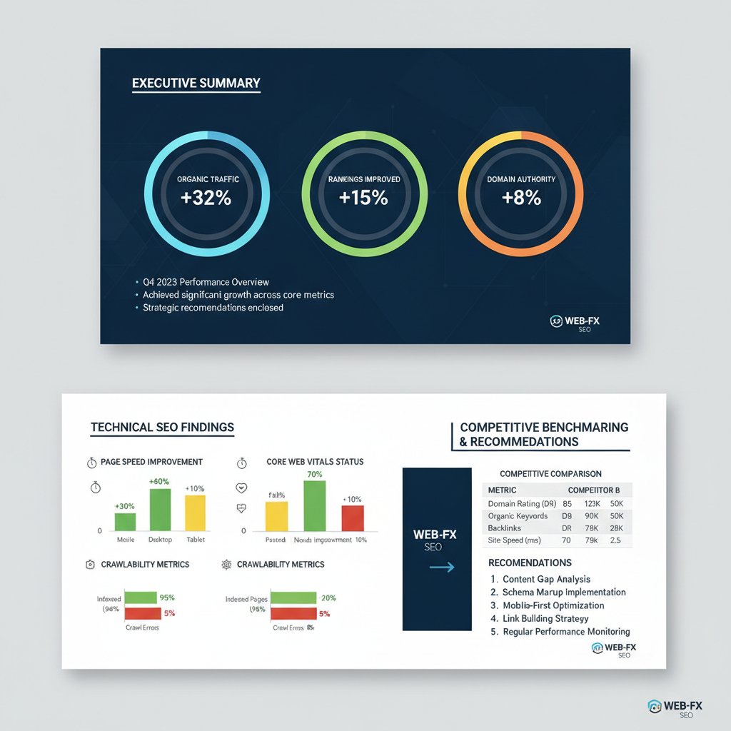
Premium SEO Audit Report Presentation Template with Executive Summary and Data Visualizations
Top SEO agencies present their findings through multiple sophisticated formats:
Dashboard and Visualization Approach
Premium reports employ data visualization tools including Google Data Studio and Looker Studio to create interactive, real-time client dashboards. These dashboards typically display:^{[9]}
- Performance overview with weekly and monthly trending data
- Best and worst performer analysis (pages with most/least traffic movement)
- Technical health status with color-coded indicators (red/yellow/green)
- Top 10 search queries driving traffic by landing page
- International market performance breakdown
- Indexation and crawlability status distribution^{[10]}
Slide Deck Presentations
Agencies deliver comprehensive PowerPoint presentations featuring:^{[11]}
- Executive summary with critical insights and projected improvements
- Technical SEO analysis with donut and bar charts showing page speed metrics, Core Web Vitals, and HTTP/HTTPS security
- Indexation status visualization categorizing URLs as valid, invalid, or error states
- Site speed and performance dashboards with HTML loading speeds and performance scores
- Crawlability and mobile optimization sections
Report Structure Components
Professional premium audits follow this structure:^{[12][13]}
- Executive Summary - 1-2 paragraphs highlighting critical insights, site performance metrics, and overall improvement potential
- Technical Health Assessment - Crawlability, indexation, site speed, Core Web Vitals, mobile responsiveness
- On-Page Factors - Title tags, meta descriptions, heading structure, keyword optimization
- Content Evaluation - Gaps, cannibalization, thin content, freshness signals
- Backlink Analysis - Live backlinks, authority evaluation, trust signals, acquisition opportunities
- Competitive Comparison - Benchmarking against 2-3 competitors with visual comparison tables
- Actionable Recommendations - SMART goals (Specific, Measurable, Achievable, Relevant, Time-bound) with priority ranking
- Implementation Roadmap - Step-by-step guidance with estimated timelines and resource requirements
- ROI Projections - Estimated traffic and revenue impact of implementing recommendations
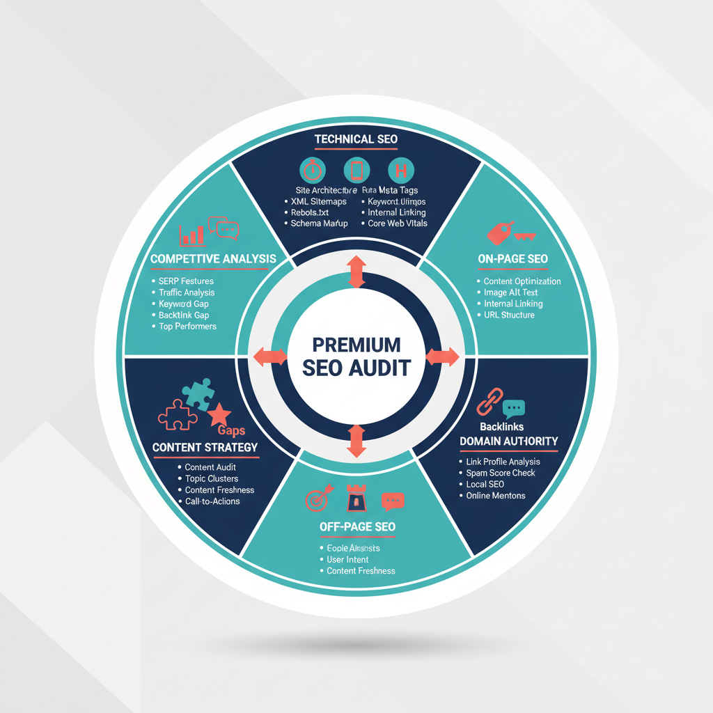
Comprehensive SEO Audit Components and Deliverables Breakdown
Data Presentation Methods
Premium audits leverage multiple visualization types:^{[14]}
- Bar graphs for comparing metrics across pages or competitors
- Pie charts for content type distribution or traffic sources
- Line charts for trending keyword rankings and organic traffic over time
- Heat maps for identifying problem areas on pages
- Infographics for summarizing complex technical findings
- Color-coded scores (green/yellow/red) for quick status assessment
Specialized Reporting Features
Enterprise-level audits include:^{[10]}
- Side-by-side comparative tables showing current month vs. previous periods
- Top performer identification with automatic flagging of pages gaining momentum
- Concern alerts for pages experiencing 30%+ traffic drops
- Keyword-to-URL mapping showing which queries drive traffic to specific pages
- Technical issue distribution charts highlighting page states (indexed, blocked, rendering issues)
- Regional performance analysis for international markets with trend comparisons

Pricing and Service Scope
Premium SEO audits typically range from $5,000 to $8,600+ per month for custom enterprise solutions. The price variation depends on:^{[15][16][1]}
- Website size and complexity (small sites: $1,000-$1,500; large enterprise: $10,000+)
- Number of pages requiring deep review
- Depth of competitor analysis required
- Implementation support and training hours included
- Access to proprietary agency tools and dashboards
- Follow-up consultation and recommendations refinement
Turnaround timelines vary from 14 to 42 days depending on site complexity, with most comprehensive audits completing within the 30-45 day range.^{[17][15]}
The key differentiator among premium agencies is their emphasis on connecting technical findings to business outcomes, offering ROI-focused prioritization of fixes, and providing implementation support rather than simply identifying issues.
⁂

- https://www.webfx.com/seo/services/seo-audits/
- https://www.webfx.com/seo/services/
- https://www.singlegrain.com/search-everywhere-optimization/best-expert-seo-agencies-for-advanced-technical-audits/
- https://thriveagency.com/news/seo-audit-what-it-is-and-how-to-do-it/
- https://thriveagency.com/digital-marketing-services/seo-audit-services/
- https://the7eagles.com/technical-seo-site-audit-agency/
- https://in.npdigital.com/website-audit/
- https://neilpatel.com/blog/seo-website-audit/
- https://seranking.com/blog/looker-studio-seo-templates/
- https://www.coupler.io/dashboard-examples/enterprise-seo-dashboard
- https://slidemodel.com/templates/technical-seo-audit-powerpoint-template/
- https://digitalanalystteam.com/5-tips-for-writing-a-killer-seo-audit-report/
- https://whitehat-seo.co.uk/blog/seo-audit-guide
- https://surferseo.com/blog/seo-audit-template/
- https://www.danielfoley.co.uk/technical-seo-audit/
- https://weareyellowball.com/guides/how-much-do-paid-seo-audit-services-cost-2/
- https://backlinko.com/templates/marketing/seo-audit
- https://www.loopexdigital.com/blog/best-seo-audit-companies
- https://www.optuno.com/blog/top-10-small-business-seo-companies-in-2024
- https://www.spinxdigital.com/guides/seo-companies/
- https://www.outrank.so/blog/b2b-seo-agency
- https://www.insites.com/the-10-best-website-and-seo-auditing-tools
- https://www.clickintelligence.co.uk/guides/agency-lists/seo/best-seo-audit-agencies/
- https://webhivedigital.com/seo-audit-services/
- https://asana.com/templates/seo-audit
- https://www.seodiscovery.com/blog/top-10-best-seo-companies/
- https://www.embarque.io/post/technical-seo-audit-service
- https://jamestaylorseo.co.uk/bespoke-seo-website-audits/
- https://www.sherbetdonkey.co.uk/seo-services/seo-audits/
- https://www.searchlogistics.com/case-studies/4-step-seo-audit-results/
- https://www.presentations.ai/presentation-templates/seo-report
- https://tryagainmarketing.com/digital-marketing-services/seo-deliverables-audit
- https://seo-audits.io/case-studies/
- https://www.singlegrain.com/blog/ecommerce-seo-audit/
- https://www.clickintelligence.co.uk/insights/seo-audit/
- https://www.flyingvgroup.com/seo-company-reviews/
- https://www.singlegrain.com/services/technical-seo/
- https://www.hobo-web.co.uk/the-seo-audit-tab-in-hobo-seo-dashboard/
- https://reportz.io/seo-report-templates/
- https://ninjapromo.io/technical-seo-agencies
- https://yoast.com/seo-audit/
- https://surferseo.com/blog/seo-report-template/
- https://ignitevisibility.com/seo-reporting/
- https://npdigital.com/solutions/data-analytics/front-end-development/

